8) Implementing various defuzzification methods.

->

we will see example of various defuzzification techniques.

Example: Find crisp value corresponding to following fuzzy output sets using various defuzzification methods.

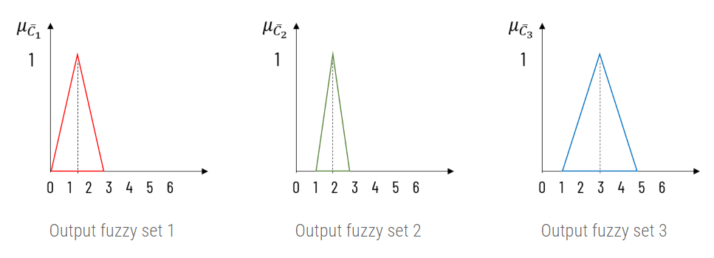

To compute the area of polygon, we need to compute the equation of line enclosing it and integrating it over lines making it.

For discussion, equation of line ab is derived here. Rest can be understand

(y – y1) / (x – x1) = (y2 – y1) / (x2 – x1)

For line ab, (x1, y1) = () and (x2, y2) = ()

(y – 0) / (x – 0) = (1 – 0) / (1.5 – 0)

y / x = 0.67

y = 0.67x

Line ab ranges from 0 to 1.5 on X axis.

* Center of Gravity method

For computing crisp value using center of gravity method, we shall find the area of overlapped region.

* Center of Sums

For computing crisp value using center of sums method, we shall find the area of individual triangle rather then overlapped region as in center of gravity method.

Area of triangle is computed as, A=1/2×b×h

A1 = 1/2 × 3 × 1 = 1.5

A2 = 1/2 × 2 × 1 = 1

A3 = 1/2 × 4 × 1 = 2

Putting all these values in the equation of center of sums method

For computing crisp value using center of largest area method, we shall find the centroid of area of largest triangle.

From the line equations we have derived,

A3 is the largest area. Lets find the center of it.

* Weighted Area Method

Weighted area method finds weighted sum of center of area and its membership value.

Center of fuzzy sets 1, 2 and 3 is 1.5, 2 and 3 respectively. And corresponding membership value of them is 1. Crisp value using this methods is computed as,

* Maxima Methods

Maxima method finds the membership value of peak at certain position.

First of Maxima: x\* = 1.5

Last of Maxima: x∗ = 3

Middle of Maxima: Not Applicable

Height Method: Not Applicable